**//WAP in Joomla to Create the Article.**

Step 1- Log into your Joomla admin area

Click + under Content > Articles

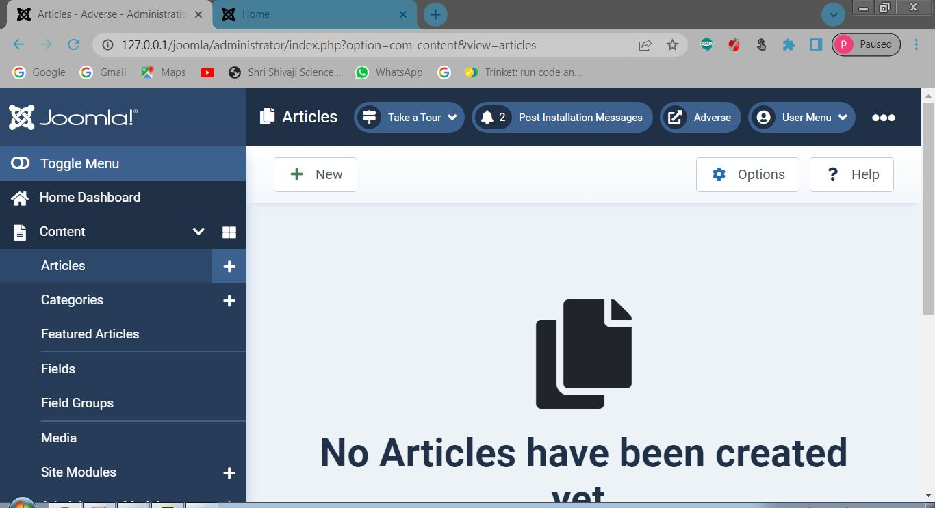

Step 2- Fill in the title field

And Start write Article

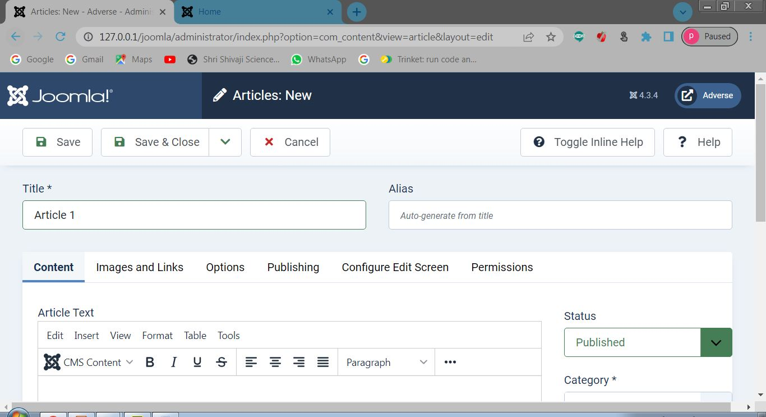

Step 3- Check on the Home page

